The Hitchhikers Guide to iBeacon Hardware: A Comprehensive Report by Aislelabs

3 Nov 2014 by aislelabs

In this report we examine 16 different iBeacon hardware vendors, including Estimote, Kontakt, and Gimbal. Over the past three months, we have stress tested the beacons under many conditions examining every aspect of them. This is the first and most comprehensive report of its kind.

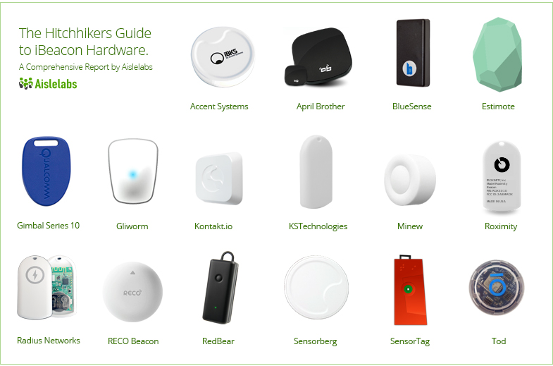

Introduction

**Contents**

1. [Introduction](http://www.aislelabs.com/reports/beacon-guide/#intro)
2. [Introduction to Beacons](http://www.aislelabs.com/reports/beacon-guide/#introbeacons)
   * [Hardware](http://www.aislelabs.com/reports/beacon-guide/#introbeacons)
   * [Firmware](http://www.aislelabs.com/reports/beacon-guide/#introbeacons)
   * [Cloud Platform](http://www.aislelabs.com/reports/beacon-guide/#introbeacons)
   * [Mobile SDK](http://www.aislelabs.com/reports/beacon-guide/#introbeacons)
3. [Chipsets](http://www.aislelabs.com/reports/beacon-guide/#chipsets)
   * [Nordic Semiconductors](http://www.aislelabs.com/reports/beacon-guide/#chipsets)
   * [Texas Instruments](http://www.aislelabs.com/reports/beacon-guide/#chipsets)
   * [Bluegiga](http://www.aislelabs.com/reports/beacon-guide/#chipsets)
   * [Gimbal](http://www.aislelabs.com/reports/beacon-guide/#chipsets)
4. [Methodology](http://www.aislelabs.com/reports/beacon-guide/#method)
5. [Vendors](http://www.aislelabs.com/reports/beacon-guide/#vendors)
   * [Accent Systems](http://www.aislelabs.com/reports/beacon-guide/#accent)
   * [April Brothers](http://www.aislelabs.com/reports/beacon-guide/#april)
   * [Bluesense Networks](http://www.aislelabs.com/reports/beacon-guide/#bluesense)
   * [Estimote](http://www.aislelabs.com/reports/beacon-guide/#estimote)
   * [Gimbal](http://www.aislelabs.com/reports/beacon-guide/#gimbal)
   * [Glimworm](http://www.aislelabs.com/reports/beacon-guide/#glimworm)
   * [Kontakt.io](http://www.aislelabs.com/reports/beacon-guide/#kontakt)
   * [KStechnologies](http://www.aislelabs.com/reports/beacon-guide/#kst)
   * [Minew](http://www.aislelabs.com/reports/beacon-guide/#minew)
   * [Radius Networks](http://www.aislelabs.com/reports/beacon-guide/#radius)
   * [RECO](http://www.aislelabs.com/reports/beacon-guide/#reco)
   * [RedBear Lab](http://www.aislelabs.com/reports/beacon-guide/#redbear)
   * [Roximity](http://www.aislelabs.com/reports/beacon-guide/#roximity)
   * [Sensorberg](http://www.aislelabs.com/reports/beacon-guide/#sensorberg)
   * [Sensortag](http://www.aislelabs.com/reports/beacon-guide/#sensortag)
   * [Todally](http://www.aislelabs.com/reports/beacon-guide/#todally)
6. [Conclusions](http://www.aislelabs.com/reports/beacon-guide/#conc)

Apple announced iBeacon technology to help smartphones identify their position and location in indoor spaces. The technology is based on the standard [Bluetooth Low Energy (BLE)](http://www.aislelabs.com/blog/2014/06/06/what-is-bluetooth-low-energy/) protocol, and is supported on all major smartphones including both Android and iPhone.

[iBeacon](http://en.wikipedia.org/wiki/IBeacon) refers to tiny battery powered devices which emit Bluetooth LE signals. The iBeacons, or just beacons, transmit a unique signal multiple times every second which can be received by phones within a few meter radius. Phones can accurately position themselves by receiving signals from all nearby beacons. The mechanism is very similar to how ships used to use lighthouses – the lighthouse would emit light which was picked up by passing by ships.

Unlike GPS, beacons can be used for accurate positioning indoors. Numerous applications have emerged – including indoor navigation, location based marketing, location based customer service, clienteling, and personalized assistance. Since the beacons use standard Bluetooth LE, it is supported well on both Android and iOS.

As the name suggests, the Low Energy variant of Bluetooth is extremely power efficient. In our [previous report](http://www.aislelabs.com/reports/ibeacon-battery-drain-iphones/), we examined the impact of beacons on both iPhone and [Android](http://www.aislelabs.com/reports/ibeacon-battery-phones/). Under real-life scenarios,a phone’s battery drain should be less than 1% because of nearby beacons. In this report, we examine battery life of beacons themselves.

Beacons have been gaining popularity recently. Numerous beacons exist in the market. The majority of them are powered by battery. In this report we present the first comprehensive comparison of various beacon hardware available in the market. Beacons come in all form and shapes, with diverse chipsets, battery sizes and firmware. We have stress tested beacons from 16 different vendors over past three months, examining every aspect of them under different conditions. In our previous report, we compared the impact on the phone battery (link), in this report we compare the beacons themselves across different parameters.

Battery consumption behavior of beacons is very important, especially when deploying them in a large enterprise setting. With thousands of beacons in field, monitoring for their battery levels and replacing them as battery drains can be a significant undertaking. It is therefore desirable to use beacons with longer battery life.

Highlights of the report are:

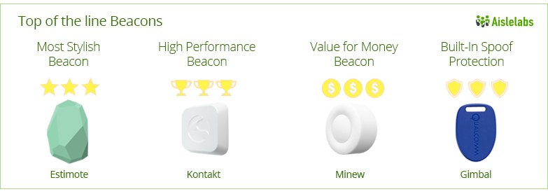

Introduction to Beacons

Beacons are small battery powered devices. They emit a BLE signal. The signal is picked up by the phone, and often transmitted to a cloud server via the internet. The backend cloud server processes the information and performs further analysis guiding specific location based behaviors in the mobile device.

Beacons consist of four primary components which we detail below:

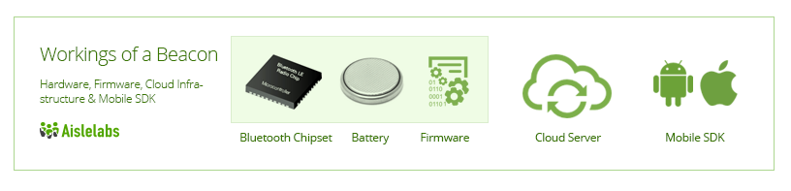

Beacon Hardware

The hardware consists of a microcontroller with a Bluetooth LE radio chip and a battery. New radio chips are optimized for Bluetooth LE, whereas older versions were designed for Bluetooth Classic which had higher power consumption. The radio chip is commonly manufactured by two major companies: 1) Texas Instruments and 2) Nordic Semiconductor. Companies such as BlueGiga and Gimbal use the underlying hardware from Texas Instruments (TI) but with their custom firmware before selling them to beacon vendors.

Coin cell batteries are the most popular choice for most beacons. These batteries are dense Lithium Ion cells and provide up-to 1,000 mAh of stored power in a very small form factor. Commonly available[coin cell](http://en.wikipedia.org/wiki/List_of_battery_sizes#Lithium_cells) sizes are 240 mAh (CR2032, small size), 620 mAh (CR2450, medium size) and 1,000 mAh (CR2477, large size). Coin cell batteries are otherwise commonly used in key fobs and digital watches.

Some beacons also use [Alkaline AA batteries](http://en.wikipedia.org/wiki/AA_battery), which are commonly used in digital cameras and TV remotes. A typical AA battery provides around 2,000 mAh power but at a significantly larger size than coin cell batteries.

Lastly, some beacons are externally powered. They can be installed in a wall outlet or a USB outlet. While these beacons alleviate the concerns of battery drainage, their installation in public spaces is constrained by availability of power outlets (unless additional wiring is provisioned, which may turn costly).

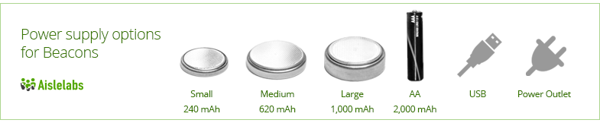

Beacon Firmware

Every beacon has a specific firmware, which is the logic (programed code) that enables the beacon hardware to operate. The firmware can control several characteristics that impact the battery life:

* **Transmit Power (tx power):** Beacon devices transmit a signal with a fixed base power, known as the tx power. As the signal travels in air, the received signal strength decreases with distance from the beacon. Higher tx power means, the signal can travel longer distances. Lower tx power means, less battery consumption but also smaller range.
* **Advertising Interval:** The rate (frequency) that a beacon emits a signal is its advertising interval. An interval of 100ms means the signal is emitted every 100 milliseconds (or 10 times in a single second). A higher interval of 500 ms means the signal is emitted only twice per second, which means less battery drain for the beacon. As the advertising interval increases, the battery life of the beacon also increases, but the responsiveness of the phone decreases. There is no optimal choice of advertising intervals, and applications needing low latency should choose lower advertising intervals, and those needing higher battery life should increase the advertising interval.

Each beacon provides its own way of configuring the hardware and associated parameters (tx power and advertising interval). Some beacons, such as Kontakt, Estimote, RadBeacon and BlueSense Networks, provide their own proprietary iPhone app to configure the beacons. Other beacons, such as Minew, provide open interface via any GATT client (such as LightBlue iPhone app or gattool on Linux). The main advantage of beacons supporting GATT method is that hundreds of beacons can be configured at once.

Some beacon hardware, such as Gimbal, also support their own proprietary beacon modes other than Apple’s iBeacon protocol. In this report, we only analyze the iBeacon mode of operation — as other modes are not fully supported by iPhones and iPads especially when the app is in background.

For our report, we compare different values of tx power and advertising interval and analyze the tradeoffs. Different beacons typically set their tx power at -12 dBmW and advertising interval between 350ms to 900ms. Tx power and maximum coverage distance of beacon, in direct line of sight, is:

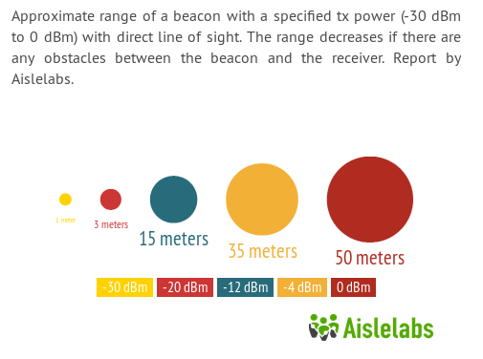

Beacon Cloud Infrastructure

Beacons provide the Bluetooth LE signal that is crucial for phones to position themselves. But these signals mean little without having an intelligent backend service. Typically, a cloud based application backed parses all received beacon signals and takes actions, acting as the brain behind all operations.

Aislelabs’ Engage platform provides an intelligent cloud infrastructure which can be used by any mobile app. Aislelabs platform also provides an [enterprise-grade beacon deployment and management](http://www.aislelabs.com/products/engage/) layer. Security and protection against beacon spoofing is also handled by the Aislelabs cloud infrastructure. We do not manufacture beacons, but work with most beacons available in the market, providing the intelligent cloud software layer to use them in large deployments.

In this report, we do not compare different cloud providers, and focus on the beacon hardware only.

Beacon Mobile SDK

Beacons have to be integrated into mobile applications so they can communicate with the cloud server, receive actions and drive location based behavior. Aislelabs provides cross platform mobile SDK that works with any type of beacon and beacon hardware in the same secure and energy efficient way. See our previous report for typical energy consumption on phones.

In this report, we focus on beacon’s battery life which is independent of the mobile SDK used.

Methodology

In order to accurately measure battery life of each beacon, we placed each beacon configured with different settings in our lab for 3 months. Over the three month period, we regularly measured the battery level (starting at 100% and decreasing over time). We also measured the current draw, in milliamperes, for each beacon.

We experimented beacons with different configuration of tx power and advertising intervals. Each beacon has its own default values, in order to compare them all, we set them to a tx power of -12 dBmW and an advertising interval of 645 ms, which we refer to as Optimized iBeacon Settings.

Since most beacons have a battery life longer than 3 months, we used the current draw to extrapolate the life beyond our experimentation period. One way to do this is to divide the battery capacity (say 620 mAh) with the current draw to get the time for complete battery drain. This assumes ideal battery, which constantly provides the said current till discharge — something that is not completely true of most Lithium Ion batteries. In real-life, the battery efficiency is closer to 75%, so we multiply the theoretical maximum battery life with 0.75 to get the final value.

**Standardized Battery Life:** We estimated the battery life of each beacon with Optimized iBeacon Settings and methodology above, which we report as the Standardized Battery Life. This metric provides a common way to compare all beacons side by side.

Below is a shot of our lab, with several beacons and test phones

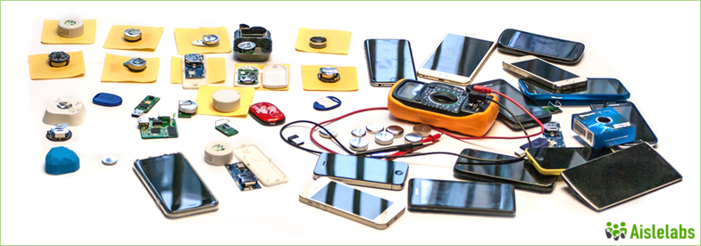

Chipsets

We focus on four primary chipsets: [Texas Instruments’ TI CC254x](http://www.ti.com/lsds/ti/wireless_connectivity/bluetooth_bluetooth-ble/overview.page), [Nordic Semiconductor’s nRF51822](https://www.nordicsemi.com/eng/Products/Bluetooth-Smart-Bluetooth-low-energy/nRF51822),[Bluegiga’s BLE112 / BLE113](https://www.bluegiga.com/en-US/products/bluetooth-4.0-modules/ble112-bluetooth--smart-module/), and lastly [Gimbal’s](http://www.gimbal.com/) proprietary controller. While there are other compatible chipsets, the above mentioned have over 95% of the market share at the time of this writing.

In this section we provide a detailed experimental study of battery consumption and power draw when using the chipsets in iBeacon mode. Chipsets from TI, Nordic and Bluegiga support different configurations for tx power and advertising interval. Gimbal provides an additional layer of Bluetooth MAC randomization, not available in other chipsets, which comes at the cost of battery drain. Gimbal beacons support only a limited set of configurations and the advertising interval can not be changed to any value other than 645ms.

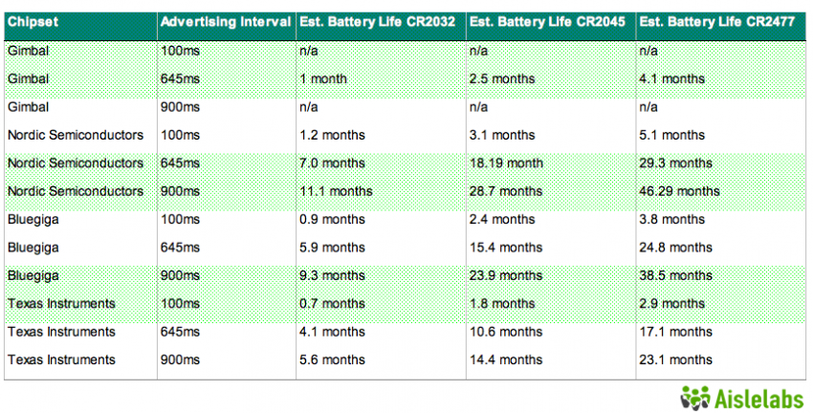

For each chipset, we summarize battery life for iBeacon Optimized Settings of 645ms advertising interval and -12dBm tx power (15 meters) using the small CR2032 coin cell battery.

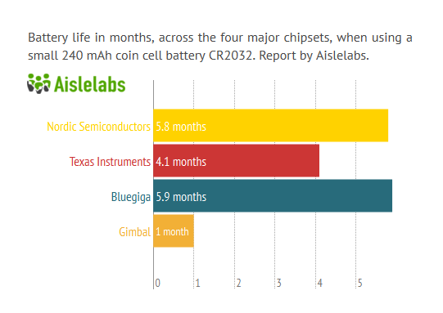

Among the four chipsets the two most prevalent chipsets are TI and Nordic. The TI chipset first became available in 2009, whereas Nordic chipset was introduced in 2012. Given this, it is reasonable to expect the Nordic chip to be more optimized for beacon-related use cases. Gimbal chipset also provides a propitiatory beacon mode, other than iBeacon protocol by Apple, but we consider only the iBeacon mode for experiments in this report. We expect these vendors to update their chipsets with newer more optimized radios in near future.

Beacon Vendors

Next we provide a list of the 16 vendors along with details:

|  |  |  |  |  |
| --- | --- | --- | --- | --- |
| http://www.aislelabs.com/wp-content/uploads/2014/11/aislelabs-ibeacon-_0015_ibks.png | Accent Systems | | | |
| http://www.aislelabs.com/wp-content/uploads/2014/11/aislelabs-ibeacon-battmanu_0015_ibks.gif | http://www.aislelabs.com/wp-content/uploads/2014/11/aislelabs-ibeacon-chip-_0002_txn.png | http://www.aislelabs.com/wp-content/uploads/2014/11/a_cr2032.png |  |
| IKBS 102 beacons, designed by Spanish company Accent Systems come with the TI chipset and a small button cell. | **Chipset**  **Texas Instruments** | **Battery**  **Small (240 mAh)** | **Life**  **4.1 Months** |

IKBS 102 beacons are designed by Spanish company Accent Systems. These beacons come with Texas Instruments chipset and are powered by 240 mAh, CR2032 coin cell battery.

Technical specifications at [manufacturer website](http://www.accent-systems.com/portfolio/ibks101-ibeacon/).

|  |  |  |  |  |
| --- | --- | --- | --- | --- |
| http://www.aislelabs.com/wp-content/uploads/2014/11/aislelabs-ibeacon-_0014_ab.png | April Brother 241 | | | |
| http://www.aislelabs.com/wp-content/uploads/2014/11/aislelabs-ibeacon-battmanu_ab.gif | http://www.aislelabs.com/wp-content/uploads/2014/11/aislelabs-ibeacon-chip-_0002_txn.png | http://www.aislelabs.com/wp-content/uploads/2014/11/a_cr2450.png |  |
| AprilBeacon 241 beacons by chinese company April Brother with the TI chipset and a medium sized coin cell. | **Chipset**  **Texas Instruments** | **Battery**  **Medium (620 mAh)** | **Life**  **10.6 Months** |

AprilBeacon 241 beacons are designed by Chinese company April Brother. These beacons come with Texas Instruments chipset and are powered by 620 mAh, CR2450 coin cell battery. Larger beacons with two AAA batteries are available, which should provide longer life of approximately 32 months.

Technical specifications at [manufacturer website.](http://aprbrother.com/en/product.htm)

|  |  |  |  |  |
| --- | --- | --- | --- | --- |
| http://www.aislelabs.com/wp-content/uploads/2014/10/p1.jpg | BlueSense Networks | | | |
| http://www.aislelabs.com/wp-content/uploads/2014/10/p4.png | http://www.aislelabs.com/wp-content/uploads/2014/10/p2.jpg | http://www.aislelabs.com/wp-content/uploads/2014/11/a_cr2450.png |  |
| BlueBar beacons, designed by UK-based company BlueSense Networks, comes with the Bluegiga chipset and a medium sized button cell. | **Chipset**  **Bluegiga BLE113** | **Battery**  **Medium (620 mAh)** | **Life**  **15.8 Months** |

BlueBar beacons are designed by UK-based company BlueSense Networks. These beacons come with Bluegiga BLE113 chipset and are powered by 620 mAh, CR2450 coin cell battery.

Technical specifications at [manufacturer website.](http://bluesensenetworks.com/announcing-bluebar-beacon/)

|  |  |  |  |  |
| --- | --- | --- | --- | --- |
| http://www.aislelabs.com/wp-content/uploads/2014/11/aislelabs-ibeacon-_0012_estimote.png | Estimote | | | |
| http://www.aislelabs.com/wp-content/uploads/2014/11/aislelabs-ibeacon-battmanu_esti.gif | http://www.aislelabs.com/wp-content/uploads/2014/11/aislelabs-ibeacon-chip-_0000_822.png | http://www.aislelabs.com/wp-content/uploads/2014/11/a_cr2450.png |  |
| Stylish beacons with colorful silicon case, by Y-combinator alum startup Estimote. | **Chipset**  **Nordic** | **Battery**  **Medium (620 mAh)** | **Life**  **22.2 Months** |

The polish startup Estimote is one of the better known beacon hardware manufacturers with slick looking beacons in a colorful silicon case. The company is now headquartered in San Francisco after graduating from Y-combinator and raising venture capital from Silicon Valley investors. These beacons come with Nordic Semiconductor’s NF51822 chipset and are powered by a 620 mAh, CR2450 coin cell battery. The beacons are completely enclosed and can be used in outdoor environment with some moisture, but this means the battery can not be replaced — new beacons has to be purchased when the battery runs out.

With the flexible silicon cover, a selection of bright colors, and reusable adhesive the Estimote beacons stand out as the most stylish among all beacons available in the market today. The company also introduced thin Estimote Stickers recently (only 3 mm deep, but with a smaller battery), but they are not yet available to the general public.

Estimote also ships with their custom firmware optimized for battery life. We have compared two versions of their firmware – version 1.9 and version 2.1 released in May 2014. All beacons ship with default tx power of -12 dBmW and advertising interval of 900ms. The new firmware made the beacons more power efficient, increasing their battery life by 15-30%.

Estimote beacons are configured via a properitory iPhone app.

Technical specifications for the beacon at [manufacturer website.](https://community.estimote.com/hc/en-us/articles/203159703-Estimote-Beacons-technical-specification)

Tables below show the battery life comparisons for both firmware versions on Estimote hardware D3.3. Note that the reported numbers below assume an ideal battery, which is not the case for real-life batteries and actual life may be lower than the numbers below.

[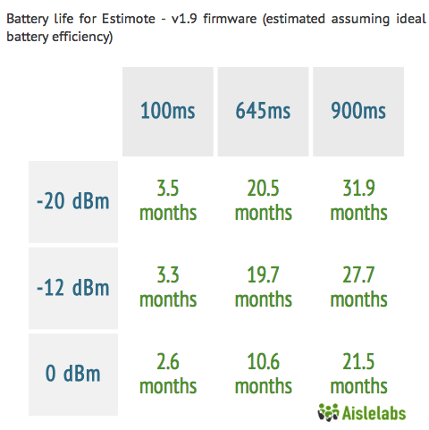](http://www.aislelabs.com/wp-content/uploads/2014/10/Sheet2Chart5.png)

[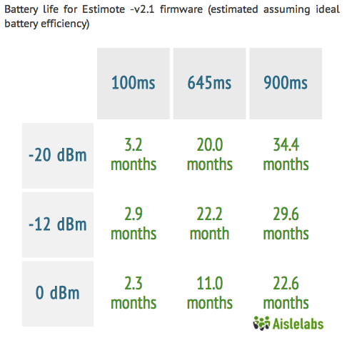](http://www.aislelabs.com/wp-content/uploads/2014/10/Sheet2Chart6.png)

|  |  |  |  |  |
| --- | --- | --- | --- | --- |
| http://www.aislelabs.com/wp-content/uploads/2014/11/aislelabs-ibeacon-_0011_Gimbal-copy.png | Gimbal | | | |
| http://www.aislelabs.com/wp-content/uploads/2014/11/aislelabs-ibeacon-battmanu_gimb.gif | http://www.aislelabs.com/wp-content/uploads/2014/11/aislelabs-ibeacon-chip-_0001_gimbal.png | http://www.aislelabs.com/wp-content/uploads/2014/11/a_cr2032.png |  |
| Slick and thin beacons by Qualcomm spinoff, Gimbal. | **Chipset**  **Gimbal** | **Battery**  **Small (240 mAh)** | **Life**  **1 Months** |

Qualcomm, the American semiconductor company better known for making Snapdragon processors, spinned off its beacon division as Gimbal earlier this year. With Qualcomm’s reputation behind it, the new company has released beacons in different form factors including Gimbal Series 10 with a small battery and Series 20 with larger AA batteries.

Gimbal beacons support two modes of operation: the Apple standard iBeacon mode and a battery optimized properitory mode. These beacons are the only beacons that change their source Bluetooth address frequently to provide a hardware layer of spoof-protection. The added hardware-supported address change is a nice addition, however it comes at a significant battery penalty. Gimbal may be the beacon of choice where hardware-based spoof protection is a necessity (spoof protection can also be provided by software-layer and cloud-based systems).

Technical specifications for the Gimbal beacon at [manufacturer website.](http://www.gimbal.com/)

The two charts below compare the battery life of the Gimbal Series 10 beacon in both iBeacon and properitory mode of operation with different tx power (in dBm) and advertising interval (in ms).

[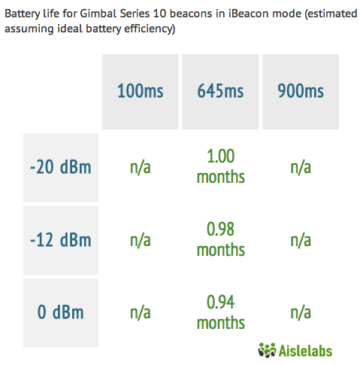](http://www.aislelabs.com/wp-content/uploads/2014/10/Sheet2Chart3.png)

[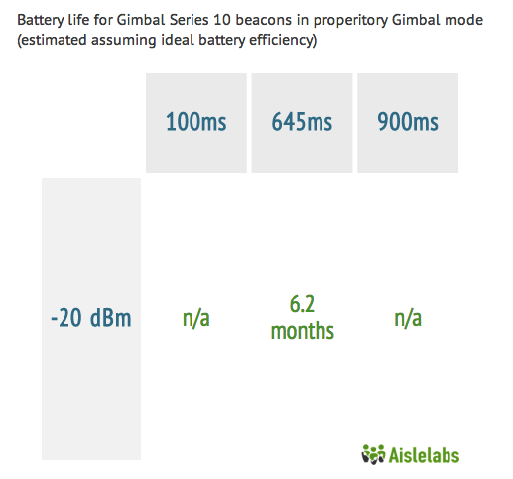](http://www.aislelabs.com/wp-content/uploads/2014/10/Sheet2Chart4.png)

Technical specifications for the Gimbal beacon at [manufacturer website.](http://www.gimbal.com/)

|  |  |  |  |  |
| --- | --- | --- | --- | --- |
| http://www.aislelabs.com/wp-content/uploads/2014/11/aislelabs-ibeacon-_0010_glimworm-copy.png | Glimworm | | | |
| http://www.aislelabs.com/wp-content/uploads/2014/11/aislelabs-ibeacon-battmanu_glim.gif | http://www.aislelabs.com/wp-content/uploads/2014/11/aislelabs-ibeacon-chip-_0002_txn.png | http://www.aislelabs.com/wp-content/uploads/2014/11/a_cr2450.png |  |
| Open source friendly beacons from the Dutch company Glimworm. | **Chipset**  **Texas Instruments** | **Battery**  **Medium (620 mAh)** | **Life**  **10.6 Months** |

Glimworm beacons are designed by the Dutch company, Glimworm. These beacons come with a Texas Instruments chipset and are powered by a 620 mAh, CR2450 coin cell battery.

Technical specifications for the Glimworm beacon at [manufacturer website.](http://glimwormbeacons.com/)

|  |  |  |  |  |
| --- | --- | --- | --- | --- |
| http://www.aislelabs.com/wp-content/uploads/2014/11/aislelabs-ibeacon-_0009_kontakt.png | kontakt.io | | | |
| http://www.aislelabs.com/wp-content/uploads/2014/11/aislelabs-ibeacon-battmanu_kont.gif | http://www.aislelabs.com/wp-content/uploads/2014/11/aislelabs-ibeacon-chip-_0000_822.png | http://www.aislelabs.com/wp-content/uploads/2014/11/a_cr2477.png |  |
| Well engineered beacons from Polish company Kontakt, with a large battery and long life. | **Chipset**  **Nordic** | **Battery**  **Large (1,000 mAh)** | **Life**  **24.3 Months** |

The brains behind these beacons are Polish company Kontak.io. Kontakt.io started out initially as a company offering a solution to aid the visually impaired navigate public spaces and enhance overall experience. Today, their beacons aim to help people from all walks of life have enriched experiences while leveraging their beacon technology.

These beacons come with a Nordic chipset and are powered by a 1000 mAh, CR2477 coin cell battery. Based on our tests we’ve found the product architecture to work quite well with this chipset, with accurate and extensive range transmission and significant power optimization.

The beacons can be configured via Kontakt.io’s own proprietary application as well as support for open standards that allow for seamless 3rd party integration.

Technical specifications for the Kontakt beacon at [manufacturer website.](http://kontakt.io/our-technology/technical-specification/)

[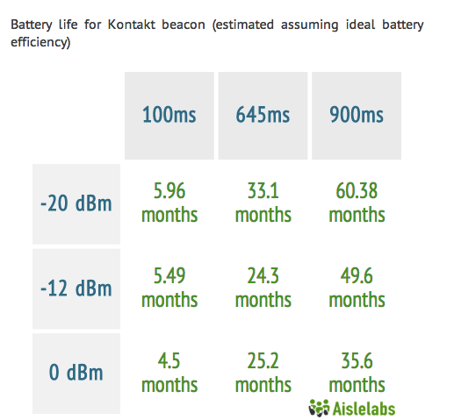](http://www.aislelabs.com/wp-content/uploads/2014/10/Sheet2Chart1.png)

|  |  |  |  |  |
| --- | --- | --- | --- | --- |
| http://www.aislelabs.com/wp-content/uploads/2014/11/aislelabs-ibeacon-_0008_kstechnologies.png | KStechnologies | | | |
| http://www.aislelabs.com/wp-content/uploads/2014/11/aislelabs-ibeacon-battmanu_kst.gif | http://www.aislelabs.com/wp-content/uploads/2014/11/aislelabs-ibeacon-chip-_0000_822.png | http://www.aislelabs.com/wp-content/uploads/2014/11/a_cr2032.png |  |
| Particle beacon from KS technologies, which is also offered by some other vendors after white-labeling. | **Chipset**  **Nordic** | **Battery**  **Small (240 mAh)** | **Life**  **5.8 Months** |

These beacons are designed by the American company, KST(KS Technologies). KST sell their beacon hardware under a brand known as Particle. They come with a Nordic chipset and are powered by a 240 mAh, CR2032 coin cell battery.

The simplicity in design makes these beacons easily customizable to fit a reseller’s exact particular requirement (firmware or hardware). KST, acting as an OEM, offer a service whereby they are able to white label with another company’s logo and even go as far as register the newly branded device with the FCC, IC and CE.

Technical specifications for the KStechnologies beacon at [manufacturer website.](https://kstechnologies.com/shop/particle/)

|  |  |  |  |  |
| --- | --- | --- | --- | --- |
| http://www.aislelabs.com/wp-content/uploads/2014/11/aislelabs-ibeacon-_0007_mw.png | Minew | | | |
| http://www.aislelabs.com/wp-content/uploads/2014/11/aislelabs-ibeacon-battmanu_minew.gif | http://www.aislelabs.com/wp-content/uploads/2014/11/aislelabs-ibeacon-chip-_0002_txn.png | http://www.aislelabs.com/wp-content/uploads/2014/11/a_cr2477.png |  |
| China-made beacons by Minew, with good quality manufacturing and a range of alternatives. | **Chipset**  **Texas Instruments** | **Battery**  **Large (1,000 mAh)** | **Life**  **17.1 Months** |

These beacons are designed by the Chinese company: Shenzhen Minew Technologies. They come with a Texas Instruments chipset and are powered by a 1000 mAh, CR2477 coin cell battery.

We were able to run our tests on the Minew MS54V3. There are 2 variants of this model also available :

1) Minew MS56 – A waterproof variant of the original MS54V3 that is covered with a soft silicone rubber shell to aid with the weatherproofing. These beacons are more suited for outdoor deployments due to their durability in several weather conditions.  
2) Minew MS55 – A variant of the MS54V3 beacons that functions with 2 CR2477 batteries. The provision for additional batteries means that these particular beacons come with a slightly larger form factor but will last for an estimated 34 months.

Technical specifications for the Minew beacon at [manufacturer website.](http://www.alibaba.com/product-detail/iBeacon-based-on-CC2541-module-with_1483638858.html)

[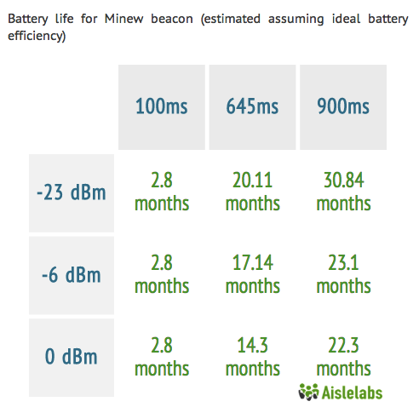](http://www.aislelabs.com/wp-content/uploads/2014/10/Sheet2Chart2.png)

|  |  |  |  |  |
| --- | --- | --- | --- | --- |
| http://www.aislelabs.com/wp-content/uploads/2014/11/aislelabs-ibeacon-_0005_radius.png | Radius Networks | | | |
| http://www.aislelabs.com/wp-content/uploads/2014/11/aislelabs-ibeacon-battmanu_radius.gif | http://www.aislelabs.com/wp-content/uploads/2014/11/aislelabs-ibeacon-chip-_0000_822.png | http://www.aislelabs.com/wp-content/uploads/2014/11/a_cr2032.png |  |
| Battery-powered beacon by American company Radius Networks, the maker of open-source beacon-related utilities. | **Chipset**  **Nordic** | **Battery**  **Small (240 mAh)** | **Life**  **4.8 Months** |

Radius Networks are an American company that make the RadBeacon Tag. These beacons come with a Nordic chipset and are powered by a by a 240 mAh, CR2032 coin cell battery.

While the RadBeacon Tag we tested worked with the CR2032 coin cell battery, Radius Networks offers a different flavor of this beacon in a USB powered variant known as the RadBeacon USB. The benefit of having a USB powered beacon is that replacing the battery becomes a non issue so long as the USB supply powering the beacon is on and functioning. However, it should be noted that this variant will be harder to deploy in a large scale environment due to the challenges of provisioning numerous power outlets to house the USB power supply per beacon.

Technical specifications for the beacon at [manufacturer website.](http://store.radiusnetworks.com/collections/all/products/radbeacon-tag-1)

|  |  |  |  |  |
| --- | --- | --- | --- | --- |
| http://www.aislelabs.com/wp-content/uploads/2014/11/aislelabs-ibeacon-_0004_reco.png | RECO | | | |
| http://www.aislelabs.com/wp-content/uploads/2014/11/aislelabs-ibeacon-battmanu_reco1.gif | http://www.aislelabs.com/wp-content/uploads/2014/11/aislelabs-ibeacon-chip-_0000_822.png | http://www.aislelabs.com/wp-content/uploads/2014/11/a_cr2450.png |  |
| Beacon by Reco, with Nordic Semiconductors chipset and a medium-sized battery. | **Chipset**  **Nordic** | **Battery**  **Medium (640 mAh)** | **Life**  **22 Months** |

These beacons are designed by the South Korean company, RECO. The beacons come with a Nordic chipset and are powered by 620 mAh, CR2450 coin cell battery.

Technical specifications for the beacon at [manufacturer website.](http://reco2.me/reco/)

|  |  |  |  |  |
| --- | --- | --- | --- | --- |
| http://www.aislelabs.com/wp-content/uploads/2014/11/aislelabs-ibeacon-_0003_red-tag.png | RedBearLab | | | |
| http://www.aislelabs.com/wp-content/uploads/2014/11/aislelabs-ibeacon-battmanu_redbear.gif | http://www.aislelabs.com/wp-content/uploads/2014/11/aislelabs-ibeacon-chip-_0002_txn.png | http://www.aislelabs.com/wp-content/uploads/2014/11/aaa.png |  |
| Larger sized beacon with two alkaline AA batteries and Texas chipset. | **Chipset**  **Texas Instruments** | **Battery**  **2x AAA (2,000 mAh)** | **Life**  **20 Months** |

These beacons are designed by Chinese company, RedBearLab. The beacons come with a Texas Instruments chipset and are powered by 2 AAA(TripleA) batteries equaling 2000 mAh.

Technical specifications for the beacon at [manufacturer website.](http://redbearlab.com/ibeacon/)

|  |  |  |  |  |
| --- | --- | --- | --- | --- |
| http://www.aislelabs.com/wp-content/uploads/2014/11/rox3.png | Roximity | | | |
| http://www.aislelabs.com/wp-content/uploads/2014/11/RoximityLogo.png | http://www.aislelabs.com/wp-content/uploads/2014/11/aislelabs-ibeacon-chip-_0000_822.png | http://www.aislelabs.com/wp-content/uploads/2014/11/a_cr2032.png |  |
| Beacons by American company Roximity with Nordic Semiconductors chipset and a small-sized button cell. | **Chipset**  **Nordic** | **Battery**  **Small (240 mAh)** | **Life**  **5.8 Months** |

These beacons are designed by American company, Roximity. The beacons come with a Nordic chipset and are powered by a 240 mAh, CR2032 coin cell battery.

Technical specifications for the beacon at [manufacturer website.](https://roximity.com/model-x/)

|  |  |  |  |  |
| --- | --- | --- | --- | --- |
| http://www.aislelabs.com/wp-content/uploads/2014/11/aislelabs-ibeacon-_0002_sensorberg.png | Sensorberg | | | |
| http://www.aislelabs.com/wp-content/uploads/2014/11/aislelabs-ibeacon-battmanu_sensorberg.gif | http://www.aislelabs.com/wp-content/uploads/2014/11/aislelabs-ibeacon-chip-_0002_txn.png | http://www.aislelabs.com/wp-content/uploads/2014/11/a_cr2450.png |  |
| Beacons from German company Sensorberg with a TI chipset and medium-sized button cell. | **Chipset**  **Texas Instruments** | **Battery**  **Medium (620 mAh)** | **Life**  **10.6 Months** |

These beacons are designed by German company, Sensorberg. The beacons come with a Texas Instruments chipset and are powered by a 620 mAh, CR2450 coin cell battery.

Technical specifications for the beacon at [manufacturer website.](http://www.sensorberg.com/en/)

|  |  |  |  |  |
| --- | --- | --- | --- | --- |
| http://www.aislelabs.com/wp-content/uploads/2014/11/aislelabs-ibeacon-_0001_ti.png | Texas Instrunment – Sensortag | | | |
| http://www.aislelabs.com/wp-content/uploads/2014/11/aislelabs-ibeacon-battmanu_ti.gif | http://www.aislelabs.com/wp-content/uploads/2014/11/aislelabs-ibeacon-chip-_0002_txn.png | http://www.aislelabs.com/wp-content/uploads/2014/11/a_cr2032.png |  |
| Development board by TI to showcase the power of their CC254x chipset and other sensors. | **Chipset**  **Texas Instruments** | **Battery**  **Small (240 mAh)** | **Life**  **4 Months** |

These beacons are designed by American company Texas Instruments. The beacons, naturally, come with their own company crafted TI chipset and are powered by a 240 mAh, CR2032 coin cell battery.

Technical specifications for the beacon at [manufacturer website.](http://www.ti.com/ww/en/wireless_connectivity/sensortag/index.shtml?DCMP=sensortag&HQS=sensortag-bn)

|  |  |  |  |  |
| --- | --- | --- | --- | --- |
| http://www.aislelabs.com/wp-content/uploads/2014/11/aislelabs-ibeacon-_0000_tod.png | tōdally | | | |
| http://www.aislelabs.com/wp-content/uploads/2014/11/aislelabs-ibeacon-battmanu_todally.gif | http://www.aislelabs.com/wp-content/uploads/2014/10/p2.jpg | http://www.aislelabs.com/wp-content/uploads/2014/11/a_cr2032.png |  |
| Bluegiga chipset powered beacons by American company Todally with a small coin cell. | **Chipset**  **Bluegiga** | **Battery**  **Small (240 mAh)** | **Life**  **5.9 Months** |

These beacons are designed by American company , tōd LLC. The beacons come with a Bluegiga chipset and are powered by a 240 mAh, CR2032 coin cell battery.

Technical specifications for the beacon at [manufacturer website.](http://www.todhq.com/index.html)

Conclusions

In this report, we have stress tested most major beacon hardware available in the market spanning 16 different vendors and 4 chipset manufacturers. After three months of extensive experimentation, with different configuration and setting on each beacon hardware and battery type, we presented our analysis. Highlights of the report are:

* Most Stylish beacon is: Estimote
* High Performance beacon is: Kontakt
* Value for Money beacon is: Minew
* Beacon with Built-in Spoof Protection is: Gimbal

A comparison of battery life across all beacons is shown in the chart below, which shows the battery life of each beacon in months (higher is better).

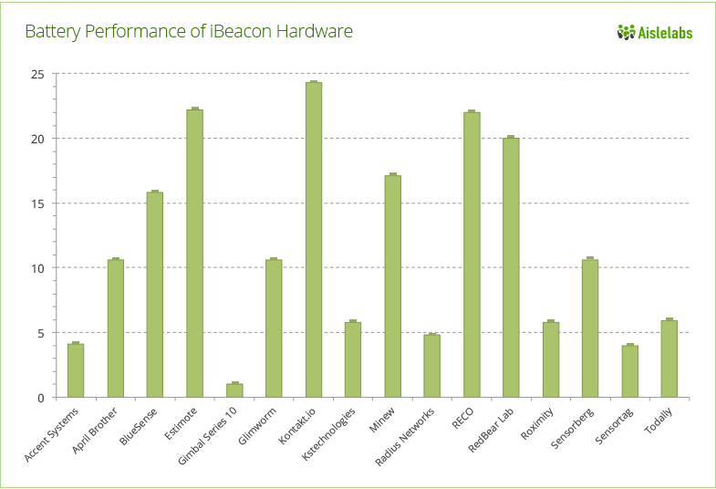

About Aislelabs

[Aislelabs](http://www.aislelabs.com/) provides an intelligent cloud platform for personalized, real-time in-store analytics and engagement. The SaaS product suite of the company includes: 1) advanced analytics solution to measure footfall traffic and consumer behavior inside and outside physical stores, similar to web analytics for e-commerce, and 2) a mobile marketing automation and engagement platform to deliver effective personalized experience. The company serves several verticals including airports, hospitality, retail and financial services.

Aislelabs’ products, [Engage](http://www.aislelabs.com/products/engage/) and [Pass](http://www.aislelabs.com/products/pass/), utilize the iBeacon technology to create hyper-local experiences. Aislelabs platform works with most major beacon hardware vendors while enabling secure beacon operation and spoof-protection via a unique patent-pending technology. The platform consists of enterprise-grade scalable beacon deployment and management platform along with intelligent cloud infrastructure for automated multi-step campaigns.

[Creative Commons License](http://creativecommons.org/licenses/by/4.0/)  
This work by [Aislelabs](http://www.aislelabs.com/) is licensed under a [Creative Commons Attribution 4.0 International License](http://creativecommons.org/licenses/by/4.0/).